Student name: Jordan Elkin
Student ID: 226621873

SIT225: Data Capture Technologies

Activity 5.1: Firebase Realtime database

The Firebase Realtime Database is a cloud-hosted NoSQL database that lets you store and sync data between your users in real-time. Data is stored as JSON and synchronized in real-time to every connected client. In this activity, you will set up and perform operations such as queries and updates on the database using Python programming language.

Hardware Required
- No hardware is required.

Software Required
Firebase Realtime database
Python 3

Steps
Step | Action
1 | Create an Account:  First, you will need to create an account in the Firebase console, follow instructions in the official Firebase document (https://firebase.google.com/docs/database/rest/start ).
2 | Create a Database:  Follow the above Firebase document to create a database. When you click on Create Database, you have to specify the location of the database and the security rules. Two rules are available – locked mode and test mode; since we will be using the database for reading, writing, and editing, we choose test mode.
3 | Setup Python library for Firebase access:  We will be using Admin Database API, which is available in firebase_admin library. Use the below command in the command line to install. You can follow a Firebase tutorial here (https://www.freecodecamp.org/news/how-to-get-started-with-firebase-using-python ).  $ pip install firebase_admin  Firebase will allow access to Firebase server APIs from Google Service Accounts. To authenticate the Service Account, we require a private key in JSON format. To generate the key, go to project settings, click Generate new private key, download the file, and place it in your current folder where you will create your Python script.  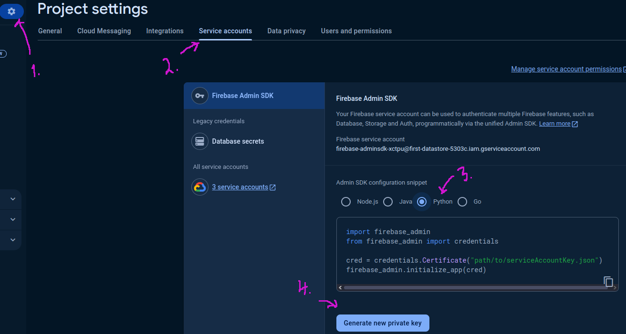
4 | Connect to Firebase using Python version of Admin Database API:  A credential object needs to be created to initialise the Python library which can be done using the Python code below. Python notebook can be downloaded here (https://github.com/deakin-deep-dreamer/sit225/blob/main/week_5/firebase_explore.ipynb ).  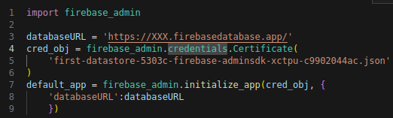  The databaseURL is a web address to reach your Firebase database that you have created in step 2. This URL can be found in the Data tab of Realtime Database.  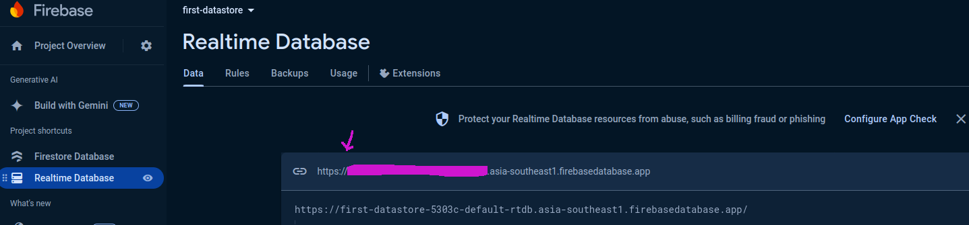  If you compile the code snippet above, it should do with no error.
5 | Write to database Using the set() Function:  We set the reference to the root of the database (or we could also set it to a key value or child key value). Data needs to be in JSON format as below.  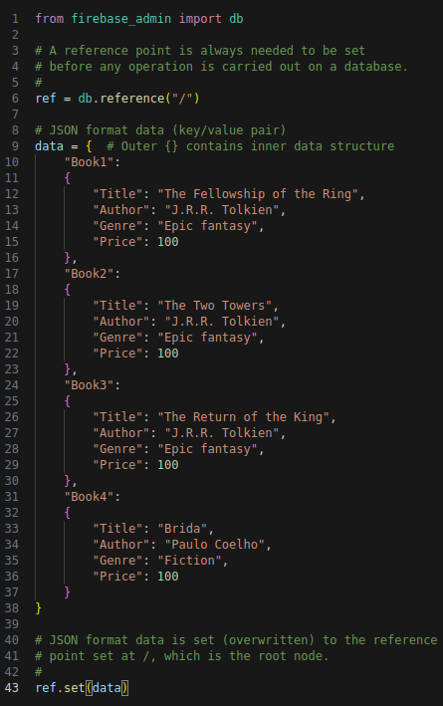  A reference point always needed to be set where the data read/write will take place. In the code above, the reference point is set at the root of the NoSQL Document, where consider the database is a JSON tree and / is the root node of the tree). The set() function writes (overwrites) data at the set reference point.  You can visualise the data in the Firebase console as below -  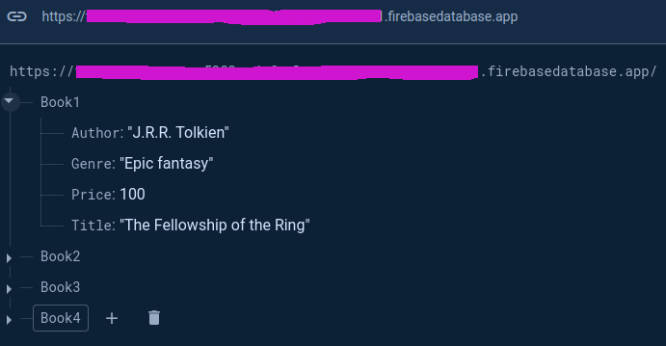
6 | Read data using get() function:  Data can be read using get() function on the reference set beforehand, as shown below.  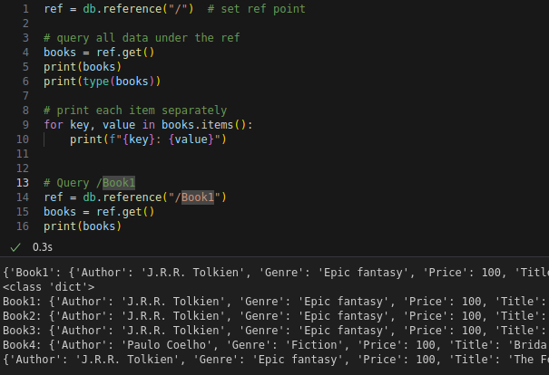  Consider the reference set in line 1 and the output compared to the reference set at line 14 and the bottom output line to understand the use of db.reference() and ref.get().
7 | Write to database Using the push() Function:  The push() function saves data under a unique system generated key. This is different than set() where you set the keys such as Book1, Book2, Book3 and Book4 under which the content (author, genre, price and title) appears. Let’s try to push the same data in the root reference. Note that since we already has data under root / symbol, setting (or pushing) in the same reference point will eventually rewrite the original data.  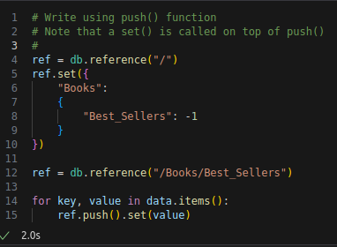  The output will reset the previous data set in / node. The current data is shown below.  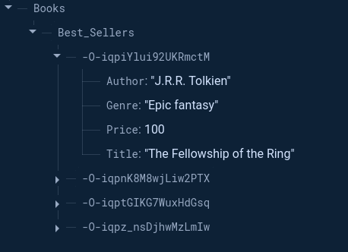  As you can see, under /Books/Best_Sellers there are 4 nodes where the node head (or node ID) is a randomly generated key which is due to the use of push() function. When data key does not matter, the use of push() function desirable.
8 | Update data:  Let’s say the price of the books by J. R. R. Tolkien is reduced to 80 units to offer a discount. The first 3 books are written by this author, and we want to apply for a discount on all of them.  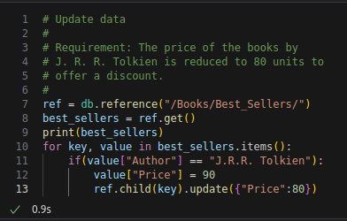  As you can see, the author name is compared and the new price is set in the best_sellers dictionary and finally, an update() function is called on the ref, however, the current ref is a ‘/Books/Best_Sellers/’, so we need to locate the child under the ref node, so ref.child(key) is used in line 13. The output is shown below with a discounted price.  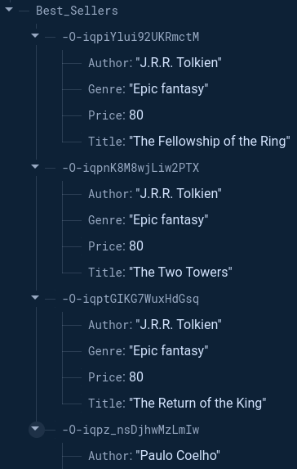
9 | Delete data:  Let's delete all bestseller books with J.R.R. Tolkien as the author. You can locate the node using db.reference() (line 4) and then locate specific record (for loop in line 6) and calling set() with empty data {} as a parameter, such as set({}). The particular child under the ref needs to be located first by using ref.child(key), otherwise, the ref node will be removed – BE CAREFUL.  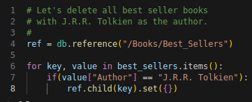  This keeps only the other author data, as shown below.  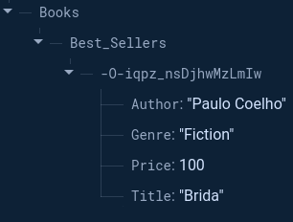  If ref.child() not used, as shown the code below, all data will be removed.  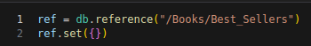  Now in Firebase console you will see no data exists.
10 | Question: Run all the cells in the Notebook you have downloaded in Step 4, fill in the student information at the top cell of the Notebook. Convert the Notebook to PDF and merge with this activity sheet PDF.  Answer: Convert the Notebook to PDF and merge with this activity sheet PDF.
10 | Question: Create a sensor data structure for DHT22 sensor which contains attributes such as sensor_name, timestamp, temperature and humidity. Remember there will be other sensors with different sensor variables such as DHT22 has 2 variables, accelerometer sensor has 3. For each such sensor, you will need to gather data over time. Discuss how you are going to handle multiple data values in JSON format? Justify your design.  Answer: The multiple files will be members of the JSON object. For example under the DHT22 object the sensor will contain a name, and its component variables and the time stamp. This will enable later analysis by grouping the sensors by name and then organising by their time stamps to create a time series graph. This will be better than other methods as the data will be stored as a record, with each record containing a unique identifier. Further, each sensor can be identified by the name variable and then the data can be passed to methods that are able to handle that particular sensor and which know what variables are apart of the sensors record type.
11 | Question: Generate some random data for DHT22 sensor, insert data to database, query all data and screenshot the output here.  Answer:  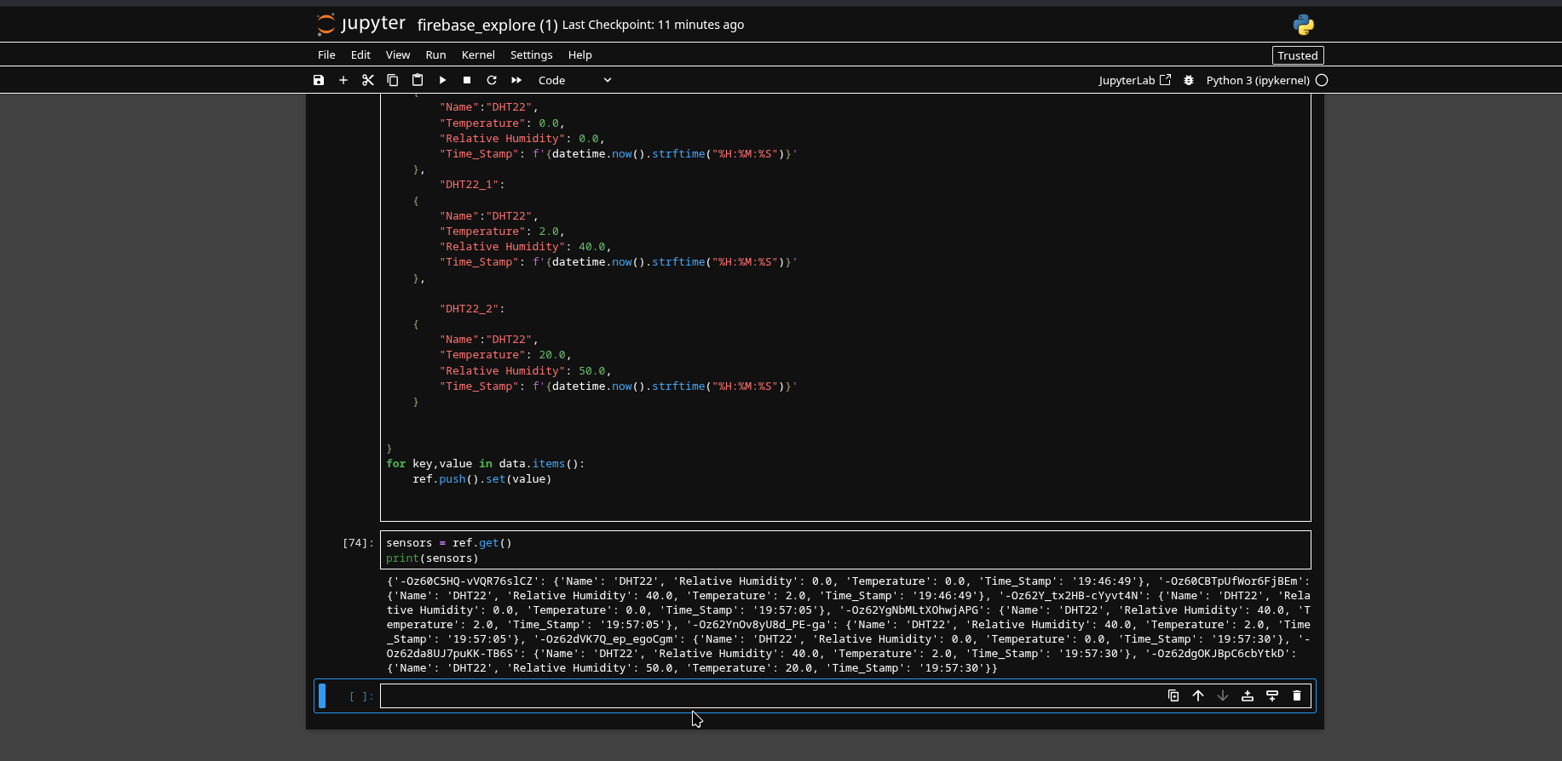
12 | Question: Generate some random data for the SR04 Ultrasonic sensor, insert data to database, query all data and screenshot the output here.  Answer:  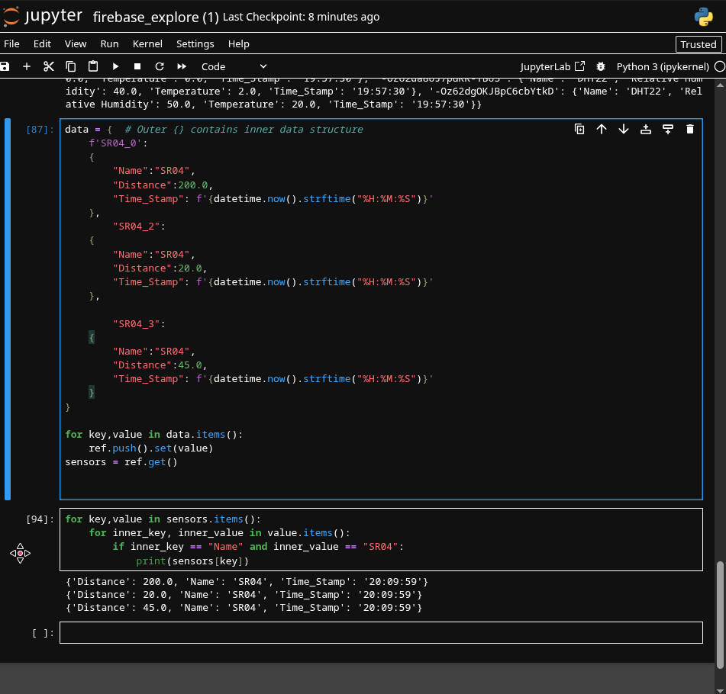
13 | Question: Firebase Realtime database generates events on data operations. You can refer to section ‘Handling Realtime Database events’ in the document (https://firebase.google.com/docs/functions/database-events?gen=2nd ). Discuss in the active learning session and summarise the idea of database events and how it is handled using Python SDK.  Note that these events are useful when your sensors (from Arduino script) store data directly to Firebase Realtime database and you would like to track data update actions from a central Python application such as a monitoring dashboard.  Answer:  Database events allow anyone using firebase or similar SDK to have variables that are automatically updated when an event is triggered through the database. This may be that it has been requested a value be updated, deleted, or created. This makes it easy to centralise information for later distribution and use throughout other software this includes dashboards and client side applications which rely on the data stored in the cloud. This is useful for the arduino as it will allow real-time, dashboards which show the current reading or state of sensors which are being used in the project. This can then be captured in a file and used for later analysis without having to create seperate csv files within python.

Activity 5.2: Data wrangling

Data wrangling is the process of converting raw data into a usable form. The process includes collecting, processing, analyzing, and tidying the raw data so that it can be easily read and analyzed. In this activity, you will use the common library in python, "pandas".

Hardware Required
- No hardware is required.

Software Required
Python 3
Pandas Python library

Steps
Step | Action
1 | Install Pandas using the command below. Most likely you already have Pandas installed if you have installed Python using Anaconda disribution (https://www.anaconda.com/download).  $ pip install pandas  A Python notebook is shared in the GitHub link (https://github.com/deakin-deep-dreamer/sit225/tree/main/week_5 ). There will be a data_wrangling.ipynb, shopping_data.csv and shopping_data_missingvalue.csv files among others. Download the week_5 folder in your computer, open a command prompt in that folder, and write the command below in the command line:  $ jupyter lab  This will open Python Jupyter Notebook where in the left panel you can see the files (labeled as 1 in figure).  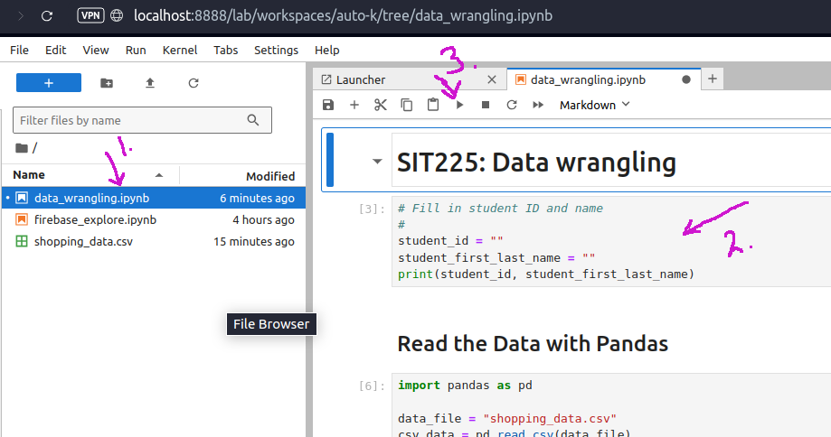  Each cell contains Python code (labeled as 2 in figure), you can run a cell by clicking on the cell, so the cursor appears in that cell and then click on the play button at the top of the panel (labeled as 3 in the figure).
2 | Question: Run each cell to produce output. Follow instructions in the notebook to complete codes in some of the cells. Convert the notebook to PDF from menu File > Save and Export Notebook As > PDF. Convert this activity sheet to PDF and merge with the notebook PDF.  Answer: There is no answer to write here. You have to answer in the Jupyter Notebook.
3 | Question: Once you went through the cells in the Notebook, you now have a basic understanding of data wrangling. Pandas are a powerful tool and can be used for reading CSV data. Can you use Pandas in reading sensor CSV data that you generated earlier? Describe if any modification you think necessary?  Answer: Yes you can utilise pandas to read the sensor data that was generated earlier for the first assignment. I did utilise pandas to read my csv file and calculate the basic statistics that I provided. Further, there was no modification required as I provided data that could be used with only the basic coercion need i.e. setting string values to integers.
4 | Question: What do you understand of the Notebook section called Handling Missing Value? Discuss in group and briefly summarise different missing value imputation methods and their applicability on different data conditions.  Answer:  The section known as handling missing values shows strategies that can be used to replace missing values with reasonable values. This includes filling with either the median or the average statistical calculation that was created using the other values in the dataset. This may be better in some situations where you’d not want to drop any data points from the visualisation that is being created. However, this is only relevant to data used in time series problems. For categorical data it is not correct to replace this data with numerical data, thus the recommendation is to replace it with an NA marker or drop it from the data set. However, in addition to the above imputation methods in the time series problems, in the general problem using numerical and continuous data, other measures such as linear regression and the mode can be used to replace values without deleting the data.

